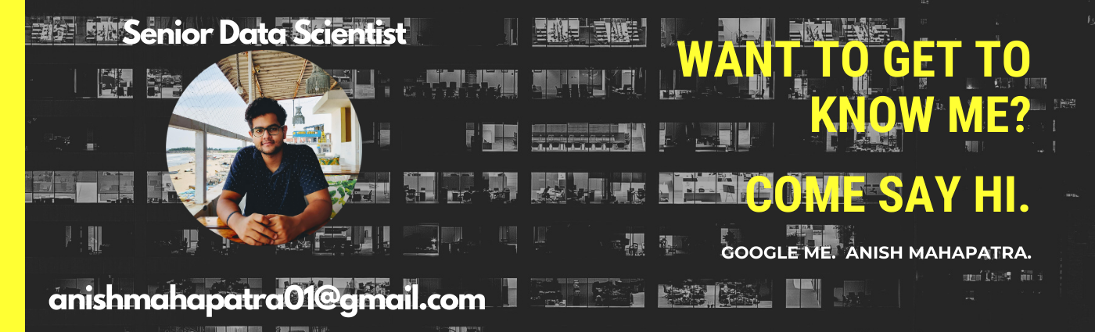

UpGrad - Point of View from a **real Data Scientist** on a Data Science course.

I have finished my PGD from IIIT Bangalore from UpGrad and am almost done with my MSc in Data Science from Liverpool John Moores University. For a working professional, there are a few things that come to mind that I can help answer.

**The short answer:**

The course was great and helped me do better at my current job and opened new opportunities in the Data Science Market for me.

If you would like to connect with me to know more, feel free to reach out to me on LinkedIn here: <https://www.linkedin.com/in/anishmahapatra/>

Email: anishmahapatra01@gmail.com

**The longer answer:**

* **Best course out there for upskilling?** Yes. The best way to judge a system is to ask someone who has done it to assess it. My pattern of the search to find the right way to upskill was the following:
  + *Udemy* (paid courses for ₹400 or so)
  + *Udacity* (Nanodegree - ₹25k)
  + *Coursera Subscription* (₹3k - ₹4k per month)
  + *UpGrad* ([Ask me](https://www.linkedin.com/in/anishmahapatra/))

Here, there are three main competitors for upskilling that I considered - Great Learning, UpGrad & Bits Pilani MTech. post all of the research and talking to alumni, UpGrad was the best option

* **Value of the degree (Local/Global)?** The certification is accepted by Canada & Visa agencies and adds points to your application for your Canada PR. If a Visa agency takes it, it is a global degree. It is WES Recognized.  
    
  Post your MSc with UpGrad; you can go ahead and pursue your PhD as well. The course is legitimate and universally accepted in every situation that would welcome a degree from the UK.
* **Is there any better learning than a YouTube video?** The quality of production with UpGrad is high. Like, not like hmm... it's nice. By high, I mean that is where most of the effort has gone.  
    
  The course is top-notch. As a Senior Data Scientist myself, I can tell you the modules that were taught were not only industry-relevant but more application-based than theory. Relevant pointers:
  + Teachers are from the industry (ex or current) from great companies such as Flipkart, Myntra, American Express etc.
  + The Professors from IIIT Bangalore are stalwarts of the industry who decided to teach post-retirement
  + The modules are on the web platform as well as on a wonderful downloadable app. You cannot scrub through the videos; you have to watch it at least once with a maximum possible speed of 1.5x before you can skip.
  + Each page has ungraded MCQs or coding questions, which you have to finish along with the videos to move to the next page.  
      
    As unappealing as this might sound, it forced me to learn. The course changed the way I look at education. I joined the program for a degree and ended up having the best learning of my life.
* **Can I do a full-time job and the course?** Yes. For the first time in your life, you are looking to do something for yourself. Since this is a decision not made by society, consider this an investment to find yourself.

My confidence in myself and my skills grew ten-fold.

Completely worth the investment.

* **Final Question:** **Is it worth it?** Maybe. I have explored the short term benefits, and they are worth it to me. The long-term benefits are to be assessed. In my head, as CXO or VP in the future, it would be nice to be labelled an MSc graduate rather than a BTech or BCom, so definitely.

The way I see it, if you were to fail a year in undergrad, for the cost of one year of education, you can get a PGD and a Master's. That has my stamp of approval.

If you have any more questions, you can reach out to me personally on LinkedIn. I will help you out to the best of my abilities. I get a lot of requests - please do add a note to your LinkedIn request that starts with Quora Request for UpGrad.

Never take diet advice from a fat person.

Check my LinkedIn to understand if I am fit to tell you about Data Science

<https://www.linkedin.com/in/anishmahapatra/>

If you are lazy or in a hurry: Email - [anishmahapatra01@gmail.com](mailto:anishmahapatra01@gmail.com)

PS - *UpGrad has a* ***referral program*** *that can help you get a substantial discount. If you are interested in knowing more about the course from a real data scientist's opinion, please feel free to ping me.*